**Exercise- Data Measurement**

**Student Name:** Animesh Johri **Student Id:** 2021292753

## **1. Science Phenomenon:**

#### **Measured the rate of my weekly weight loss for 9 weeks**

# I was on a weight loss mission for over 2 months starting from 1st November 2017 to mid of January 2018. I recorded the weight I lost after the end of each following week.

**Procedure:**

* Exercised regularly to burn at-least 350 calories for the first month in gym by running.
* After 1 month, I exercised regularly to burn at-least 400 calories.
* In the second month diet was strictly followed like sweet potato, fruits, vegetables, salads, protein rich food and no food with high carbohydrates contents.
* Measured weight on every weekend and recorded it.

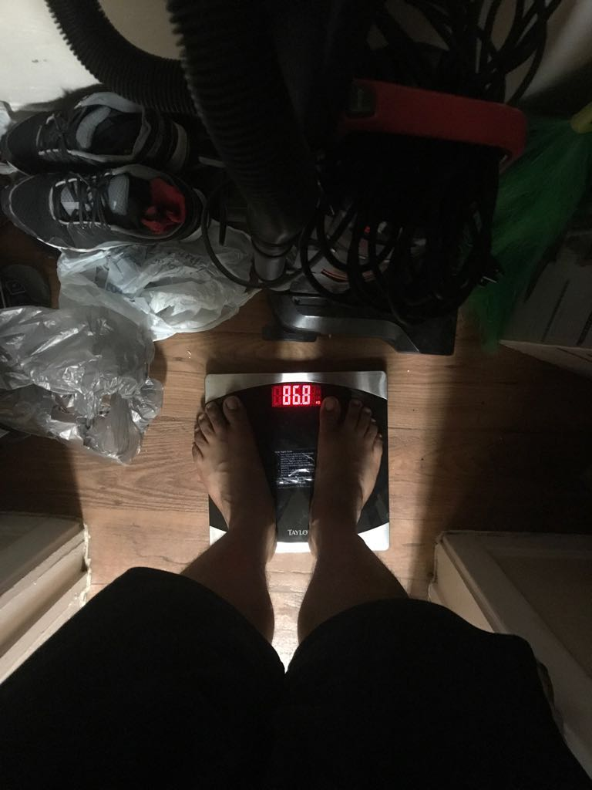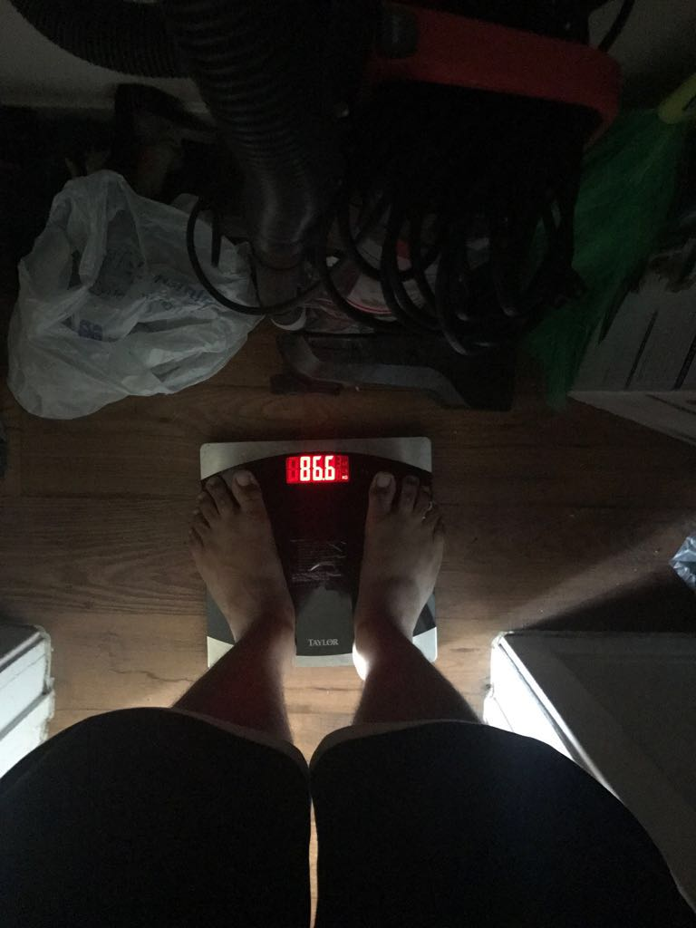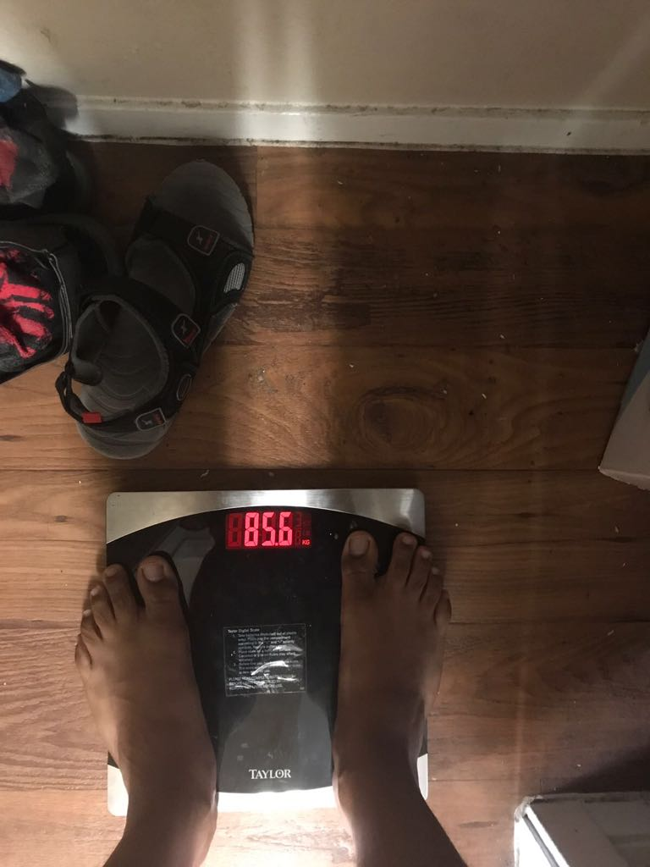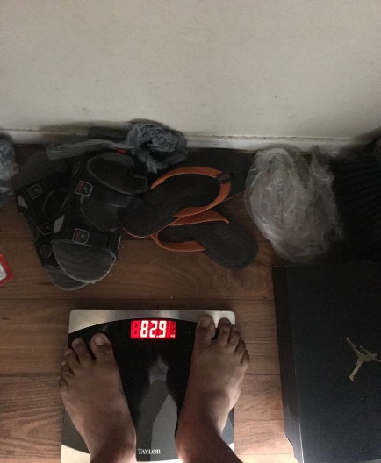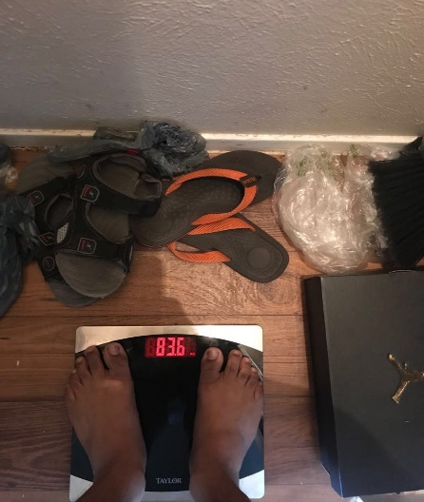

**Data Points:**

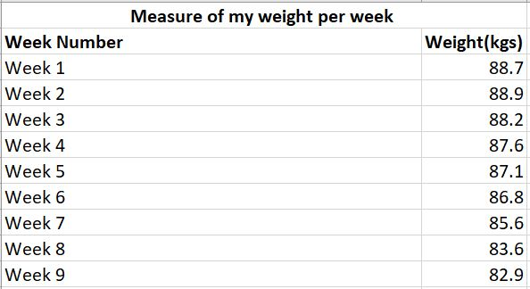

**Data Visualization:**

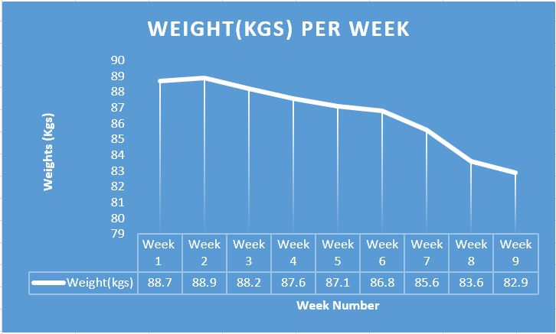

**Color coded data table:**

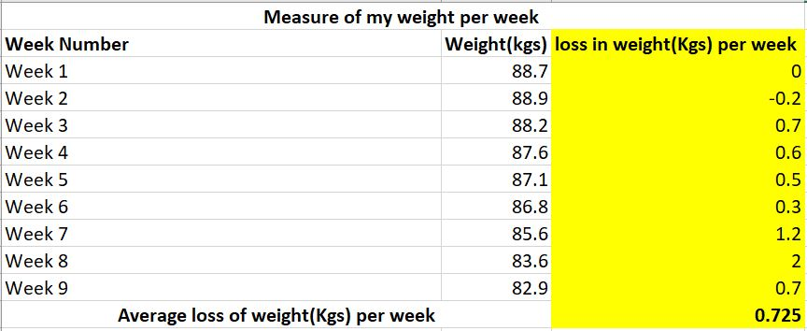

**Insights:**

1. From the graph, we can infer that there is a weight decreasing trend with each passing week.
2. Data table shows that the average loss in the weight of a person is 0.725 Kgs per week.
3. Maximum reduction in the weight occurred in the 7th week. It is during the month when more calories were burnt with a healthy and strict diet.
4. Initially the weight increased a little bit but with time the rate of weight loss increased. This shows improvement in the metabolism due to regular exercise.

**2. Business Phenomenon:**

#### **Measure of the Starbucks customer traffic throughout the day for Espresso**

Starbucks is a famous coffee outlet and many students buy coffee from there.It sometimes gets difficult to be available with the required number of employees at the counter. Moreover, the most in demand product’s raw material may also run out at the peak time. Therefore, I stood in front of Starbucks to collect data and visualize to understand the customer traffic pattern.

**Procedure:**

1. Convinced the employees to draw a line on the copy when someone buys espresso for each hour.
2. Monitored the correct data entry in my copy.
3. Calculated the total number of lines to determine total number of customers and noted it down.
4. At the end of the day, summarized whole data and visualized it.

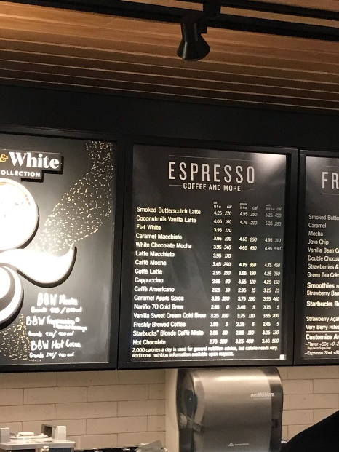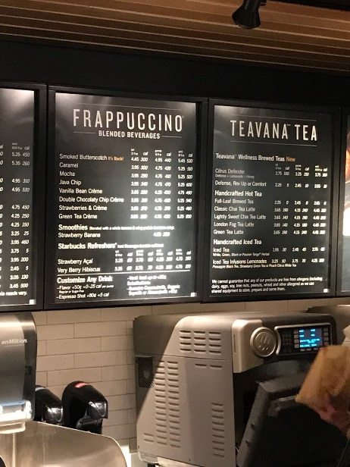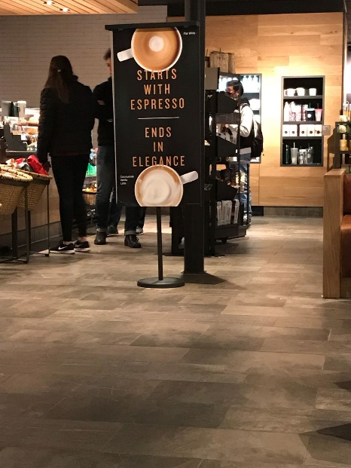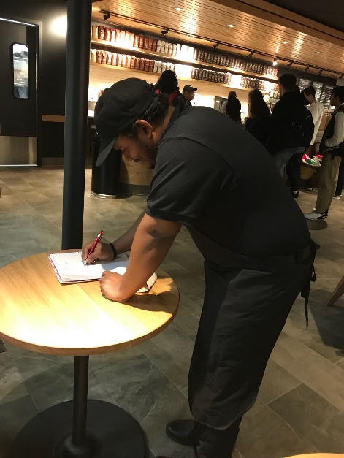

**Data points:**

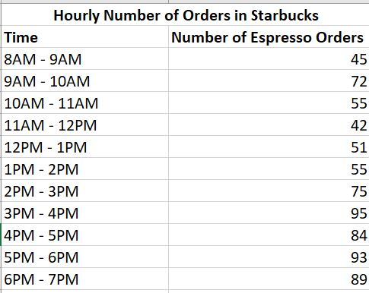

**Data Visualization:**

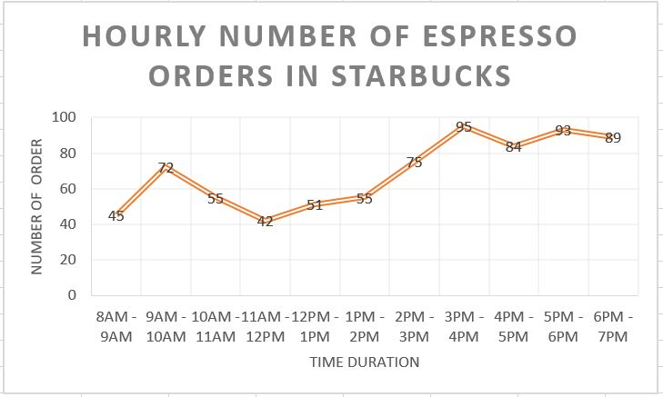

**Color coded data table:**

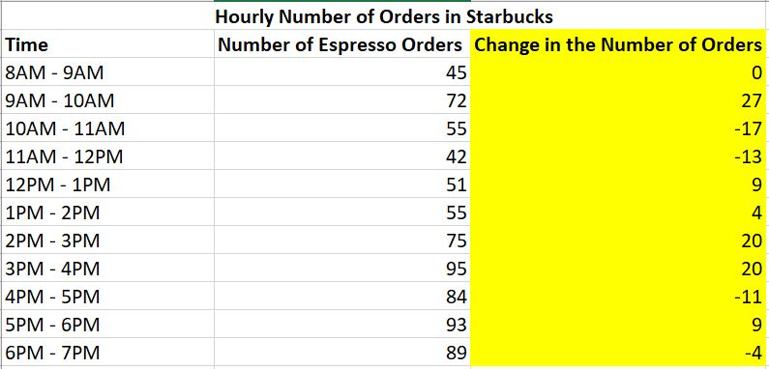

**Insights:**

1. From the data table, it can be observed that during the morning hours there is an increase in coffee consumers at around 9 AM. It is the time when people start their job or studies of the day and they need themselves active at that time.
2. From the graph, we can see that during the evening time more number of people come to sit and relax with the coffee after finishing the busy day.
3. From the color-coded table, we can infer that the highest number of increase in sale is around 4 PM.

## **3. General Observation Phenomenon:**

***Record my credit score after each week V/S the balance of credit card at that time.***

**Procedure**

To improve my credit history, I used to record my credit score each week and the balance at that time. I keep in mind the suggestion by credit karma app and make variations in the balance each week to see the effect on the credit score.

**Procedure:**

1. Record credit score and balance at the time of score generation date each week.
2. Simulate the balance suggested by the app and see the credit score.
3. Increase and decrease the balance to see the changes.
4. Repeat the above procedure.

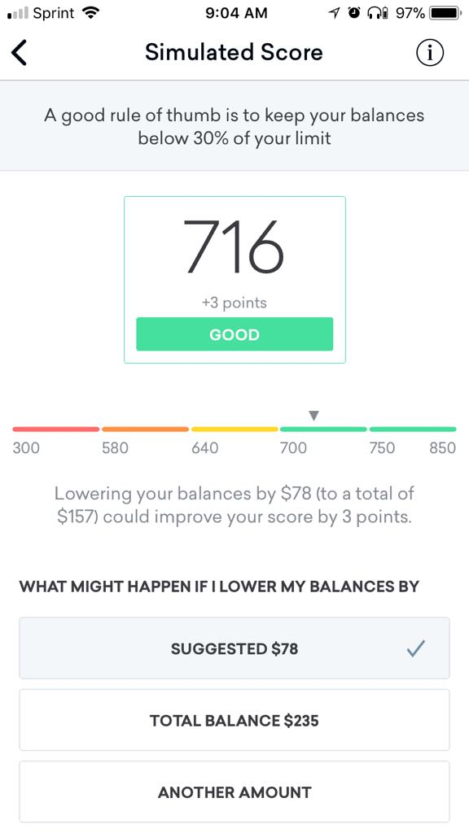

**Data points:**

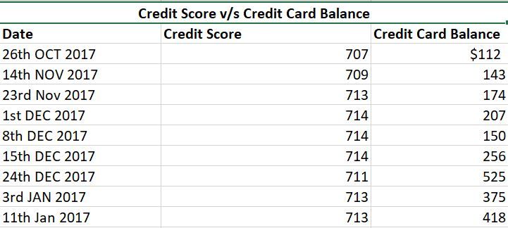

**Data Visualization:**

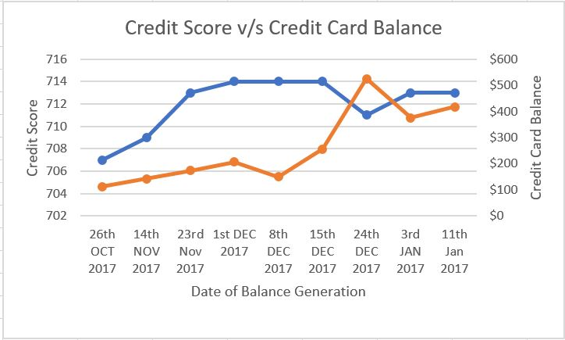

**Color coded data table:**

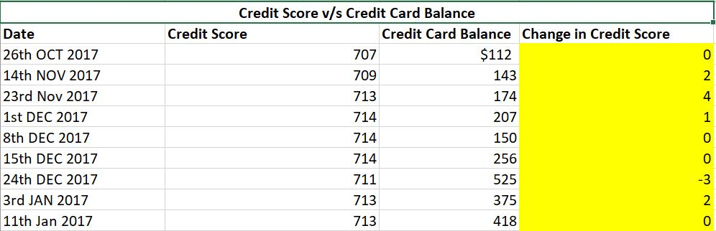

**Insights:**

* When balance crosses the 30% of the credit limit the credit score significantly drops by -3. At that time balance was $525 and 30% of credit limit was $500.
* Credit score remains almost constant when the spending is nearly constant and under the 30% of the credit limit amount.
* Paying off the balance before the statement generation data actually improved the credit score significantly as shown in the graph.